Turner School Parents & Citizens Association
Agenda
AGM 20 February 2024, 7.30pm
Turner School Staff Room

- WELCOME Chair welcomed the attendees
  - Attendees: Helen (Mel) Bell, Serina Bird, Maureen Brauers, Amanda Bruce, Michael Carbone, Allison Edmonds, Brian Familiar, Katherine Fraser, Chris Hall, Tim Kefford, Anna Lyons, Daniel Manestar, Sam Margerison, Antonia McGuire, Miranda Menaspà, Nick Miller, Emily Schuster and Liz Taggart-Speers.
  - Approval of March 2023 AGM Minutes (Chair) Moved Maureen Brauers, seconded Mel Bell.

- BUSINESS
  - President’s Annual Report (report attached)
Noted it has been a year of rebuilding connections.
Thanked the 2022 P&C for steering the organisation through covid. Thanked the 2023 team and the school.
Highlights of 2023: ran through the activities the P&C ran including: David Street Coffee Morning, Big Playdate, Disco Coffee Cart, Trivia Night, Referendum Day Sausage Sizzle, World Teacher’s Day Breakfast and the return of the Annual Turner Fete. Free end of Year Concert Barbecue to thank the community.
  - Treasurer’s Annual Report including Financial Statements and Auditor’s Report
Noted the 2023 committee took ownership of the bank account from July after some set up hold ups.
Presented the financial position and the auditor’s statement (report attached)
Over the year Crazy Camel. Income exceeded expenses over the year.
$37,947.68 in the P&C’s Commonwealth Bank account.

- ELECTION OF RETURNING OFFICER (Chair)
3.1 Allison Edmonds was appointed as Returning Officer for the following elections and all positions were declared vacant.

- ELECTION OF VOLUNTEERS TO COMMITTEE POSITIONS
2024 Turner School P&C Committee - elected unopposed
  - President – Emily Schuster
  - Vice President – Maureen Brauers
  - Treasurer – Katherine Frazer
  - Secretary – Miranda Menaspà
  - Public Officer – Michael Carbone
- BANKING
  - Signatories for the P&C Bank Account (Commonwealth Bank) to be: Treasurer, President, Vice President, Secretary
- OTHER BUSINESS
  - Meeting change times – Discussion of holding P&C meetings at 8.15am or 5pm in the library once per term. A Google Meet option can be made available. Allison to ask Laura to set up. School can’t do Wednesday. Emily to create a poll to send to those present seeking preferences for days of the week and times. Note: the School cannot do Wednesday morning or Thursdays after school. Fete meetings to be organised separately. Next meeting later in term 1.
- CLOSE (Chair) – Meeting closed a 7.53

ATTACHMENTS

- 2024 President’s report
- 2024 Treasurer’s report and audited financial statements
- 2023 AGM Minutes

President’s report – P&C AGM 20 February 2024

Thank you to the team
Thank you for making the P&C possible over the last year as we rebuilt in the post-COVID era.

I’d like to acknowledge the team of past volunteers who kept it going through COVID years – especially the 2022 team of Amanda Bruce, Aarathi Ayyar-Biddle, Nicola Gibson, Ole Nielsen, Annie O’Connor, Dale Todling, Jamie Todling and Adele Kent, as well as those who went before them.

Thank you to the main parent crew from 2023: Maureen Brauers (Vice President), Chris Hall (Treasurer), Annie O’Connor (Public Office), Emily Schuster (Communications), Stephanie Peatling (Lunches), Michelle Hasham (Crazy Camel), Mel Vote (Trivia Night), Miranda Menaspà (Fete Treasury), Robyn Ross (Election and and Fete Sausage Sizzles), Carla Giuca (Facebook Admin & Fete), Alex Kidd (Fete Donations & Barbecue Shopping), Siobhan Dickinson (Fete + Meetings) and the 27 stall holders from the Fete.

And thank you to the school: Allison Edmonds (Principal), Antonia Mguire (Deputy Principal), Heather Hill (Deputy Principal), Laura Patrick (Front Office/Newsletter and Notices) and Ted Hanlon (Facilities Manager and Fete Extraordinaire), whose attention to detail and years of experience were invaluable throughout the year and especially for the Fete.

Highlights of 2023 – building connections and having fun
We have had a huge year of rebuilding connections, starting with the David Street Coffee Cart, with Sly Fox providing coffee for parents and teachers on their way into school. It was rewarding to see parents take up the opportunity to stop and connect. We invited Sly Fox back the Junior School Disco and the 2024 Welcome Morning Teas.

We hosted a Big Playdate after school one Friday in term one to get people used to using the barbecue and to provide parents with an opportunity to connect. We encouraged people to bring a plate to share and the P&C provided a free sausage sizzle.

To celebrate Turner’s 70th Anniversary we hosted a Trivia Night at the Duxton. We filled the venue and met parents who went on to be stall holders at the Fete.

A Referendum day sausage sizzle provided us with an opportunity to test out our barbecue skills and electronic payment methods ahead of the fete, while also fund raising.

Our year of building social connections culminated in the Turner School Fete on 28 October. There were over 90 volunteers working on stalls in the lead up to the fete and across the day. The aim for the 2023 Fete was to create a fun day for the children – to this end we had a fire truck, a magician, a box maze, fairy floss, colored hair, tombola toss, photo booth, robotics stand and face painting, as well as two stages for performances. It was a great day.

In October we also hosted the World Teachers’ Day Breakfast to acknowledge and thank the school’s staff for all they do for us and our children. The bacon and egg rolls, veggie burgers, doughnuts, fruit plates, gluten free options and fresh coffee were well received.

We were able to contribute toward the Year 6 Fun Day, funding the bus trip to reduce the cost to parents. We also provided some extra food and decorations for the Year 6 dinner.

The Crazy Camel Artworks were popular again, with grateful parents receiving their orders in early December.

Lunch Orders were coordinated with Lyneham High Canteen every Friday and happily received by children each week.

We were able to provide the End of year concert barbecue as a free event as the P&C’s way of saying thank you to everyone who contributed to the school over the last year.

Farewell
Thank you for an amazing year. 2023 was my last year as a Turner parent, wrapping up more than ten years at the school. I am grateful for the friendships I’ve gained through the school community, particularly the P&C. All the best for the year ahead. I’m here if you need me, but I doubt you will.

Mel Bell
(outgoing) P&C President
Turnerprimarypanc@gmail.com

Treasurer’s Report and Audited Financial Statements

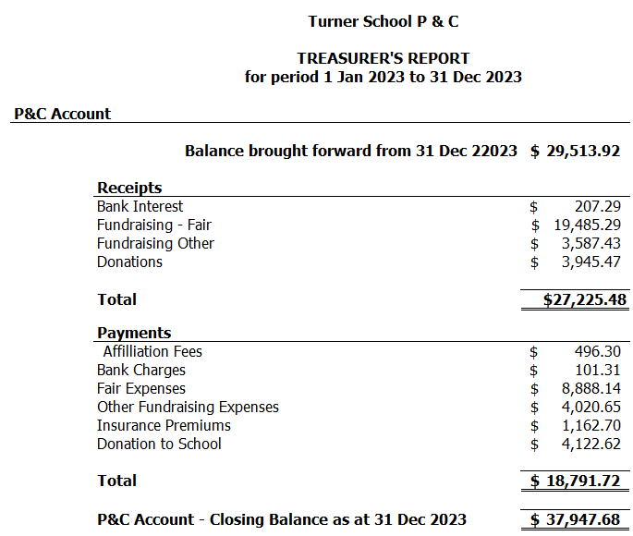
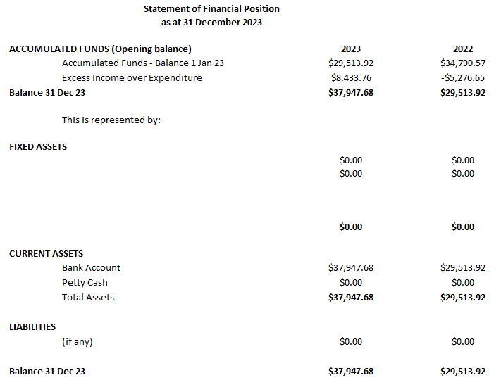

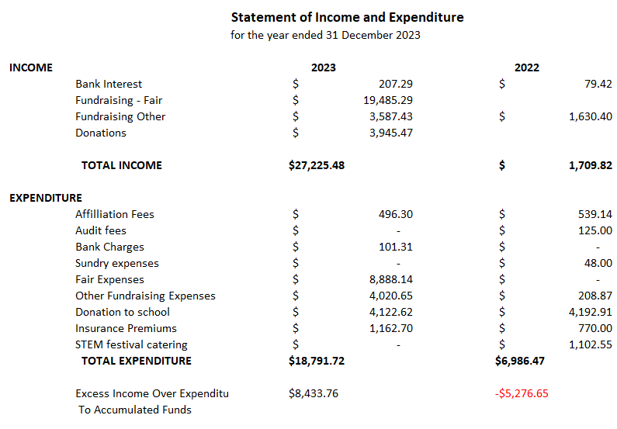

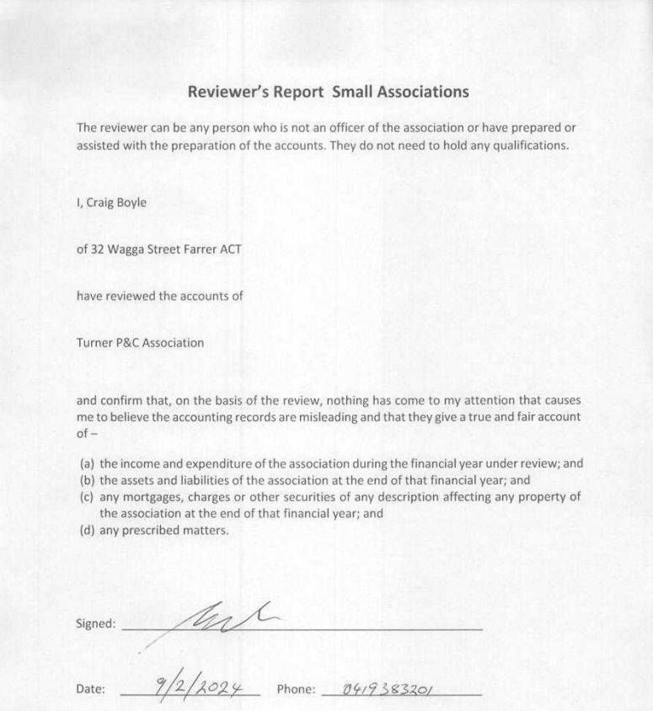

2023 AGM Minutes

Turner School Parents & Citizens Association
Minutes of the Annual General Meeting
Tuesday 28 February 2023, 7.00 pm, staff room

It is preferred that agenda items are notified to the Secretary, Vice President or President one week before the meeting and, if required, accompanied by a written report, and a written proposed motion.

The Turner School Parents and Citizens Association aims to improve the academic, social and emotional outcomes of students regardless of a student’s ability, race, gender, religion or socio-economic status.

All members should remember to be punctual and be prepared, listen without interrupting, speak briefly and criticise the ideas not the person.

1. Welcome:

    - The meeting was opened by the Chair at 7.00 pm with an acknowledgement of country, and they thanked everyone for attending.

    - Present: Amanda Bruce, Allison Edmonds, Nicola Gibson, Annie O’Connor, Antonia McGuire, Helen (Mel) Bell, Maureen Brauers, Chris Hall, Yian Noble, Heather Hill.

Apologies: Ole Nielsen

    - Previous Meeting Minutes (AGM March 2022)
It was Moved by the President and seconded by the Public Officer that the minutes of March 2022 meeting be approved. CARRIED

There was no business arising from the previous meeting.

2. Business

2.1 President’s Annual Report

2.1.1 The President gave a short verbal report and thanked all of those who contributed last year. The main fundraising activities had been Crazy Camel – with thanks to Adele, and the election day sausage sizzle. The opening of the cultural integrity garden was also a highlight, along with the community picnic. The P&C also continued to run the canteen service on Fridays. Thank you to all of those who contributed through the year.

2.2 Treasurer’s Annual Report including Financial Statements and Auditor’s Report (includes canteen accounts)

    - The report as attached to these minutes was noted. In discussion:
- We ended the year with about 28k in the account.
- We used Fiona Langford for the second year in a row for our audit, although she has indicated she is retiring and won’t be able to continue next year, and
- there is an error in the Statements and the right column should be labeled 2021.
ACTION: it was agreed that a new auditor will need to be found for 2023.

3. Election of Returning Officer

3.1.1 It was Moved by the President and seconded by the Secretary that Allison Edmonds be appointed Returning Officer for the following elections. CARRIED

3.1.2 The President step down as chair and hand over to Returning Officer. The Principal thanked all for their contributions last year.

There were initially no nominations for the President position. As a result, the group agreed to discuss the P&C connections document (item 4) in the context that the P&C, in its current state, may not be viable to continue without increased parent involvement.

4. P&C Connections and way forward for 2023

4.1.1 The P&C connections document, as attached to these minutes, was discussed, along with potential ways forward for the P&C.
- Individual activities were discussed, with options for how these might be delivered in 2023 with either P&C involvement or without a formal P&C
- In discussion about the future of the P&C, there was:
  - strong support for the P&C to continue, acknowledging that it can be difficult to identify volunteers who wish to participate as office holders
  - views that more might be done to reinvigorate parent and community interest in the P&C as parents are just now able to be on school grounds again
  - concern that many parents may not realise how fragile the P&C is, and that more could be done to communicate that, without more active volunteers, the P&C is at risk of not continuing as an entity
  - thanks expressed for the efforts of parents who had led the P&C through the COVID-19 period
  - concern that, given the 2022 Committee had been spilled, it may not be feasible from a governance perspective to transfer funds from the P&C account to the school (should the P&C lapse this evening). It was also noted that operating funds would need to be left in the P&C account as a ‘float’ to cover expenses such as an audit, seeking advice etc. Consideration was given to seeking advice from Access Canberra
  - agreement that a ‘pipeline’ of volunteers is needed to ensure the viability of the P&C in 2023 and beyond, including to identify a President for 2024
  - discussion of a model where there is no formal P&C, but parents take the lead for coordinating an activity or service (for example the way the canteen currently runs very successfully)
  - agreement that it is not reasonable to expect the school to pick-up the administrative burden of coordinating activities that have been P&C led in the past
  - acknowledgement that the connection between parents and the school is paramount.

There was agreement from the group to resume the election.

5. Election of volunteers to committee positions

5.1.1 Helen Bell was nominated as President, seconded by Amanda Bruce. There were no other nominations, it was noted this will be a single one-year term for Hellen as her youngest child is in year 6 this year. CARRIED

5.1.2 Helen nominated Maureen Brauers as Vice-President, seconded by Annie. There were no other nominations. CARRIED

5.1.3 Helen nominated Amanda Bruce as Secretary, seconded by Chris. There were no other nominations. CARRIED

5.1.4 Chris Hall nominated himself as Treasurer on an interim basis, seconded by Amanda. There were no other nominations. CARRIED

A Treasurer will be sought via a call for additional volunteers for the P&C via the newsletter etc.

5.1.5 Nicola nominated Annie O’Connor as Public Officer, seconded by Amanda. There were no other nominations. CARRIED

5.1.6 The Returning Officer handed over to Helen, in her capacity as President.
The 2023 committee is:
President: Helen Bell
Vice President: Maureen Brauers
Treasurer: Chris Hall
Public Officer: Annie O’Connor
Secretary: Amanda Bruce

5. Other business

5.1.1 Other business will be covered off in the general meeting to follow the AGM

6. Closure

6.1 The Chair closed the meeting at 8.20 pm

